​Website Revisions 4-7-26
Home Page
- On the Home Page, remove the “Call our Office black button at the top left side of the page and the “Contact Us” and “Call Us Now” buttons at the bottom of each slider.
- Separate “Mediation” and “Coaching”.
Instead of having Mediation and coaching say only “Mediation”
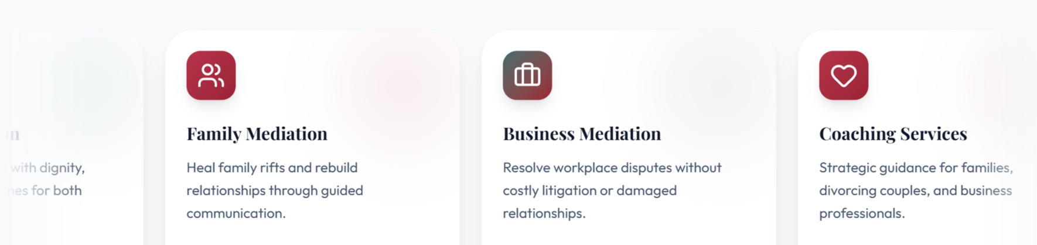and also remove coaching and use the content on the Mediation service tabs.
- Change “Mediation & Coaching Built Around you” to
“Mediation Services Focused on Delivering Effective Outcomes”
- Put moving boxes regarding mediation only under this title.
- Type a separate section for “Coaching Services”.
- Under “Coaching Services” paste the following message:

Our coaching services assist individuals, couples, families and businesses in setting goals, improving skills, and achieving results through customized support and actionable steps.

- Please make the following changes on the “Mediation Page”:
a. Remove the slider with the attached photo #264 that is attached and replace the photo of the white family with photo #264 on the header on the Mediation page.
b. Move the photo closer to the wording.
c. Use the same font for "The Path from Conflict to Resolution" as "Family and Divorce Mediation" on the Mediation page.
d. Remove “Start Your Mediation” from all places on the website.
e. On the Mediation Header, replace “Start Your Mediation” with “Schedule Your Consultation Today” with the phone number.
3. Do not include this sentence yet: Coaching services tailored to formulate effective and implementable strategies.
4. On the slides always use the thin line like you used in other places and also bring the words and the picture closer to avoid big spaces between the picture and words.

